WE have 3 tables coming from 3 different datasources

Table 1- Order (csv file) – It has 250 distinct unique Order_ID

Columns: Order_ID, Items, Amount, Customer_ID

It doesn’t have any error or empty data

Table 2 – Shipping (json file) – It has 250 distinct unique Shipping_ID

Columns: Shipping_ID, Status, Customer_ID

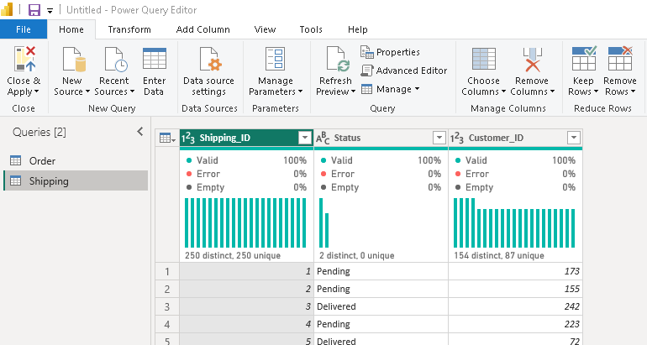

It doesn’t have any error or empty data

Table 3: Renamed to Customer (xls file converted to xlsx) - It has 250 distinct unique Customer_ID

Columns: Customer_ID, First, Last, Age, Country

It doesn’t have any error or empty data

All the 3 tables are connected through Customer_ID using Many to One Relationship and filtering from both sides (Data Flow)

* For finding the the total amount spent and the country for the Pending delivery status for each country we need to filter on status as “Pending” and group by Country

* the total number of transactions, total quantity sold, and total amount spent for each customer, along with the product details.

* The maximum product purchased for each country

We need to find the count of Order_ID group by Country

* the most purchased product based on the age category less than 30 and above 30.

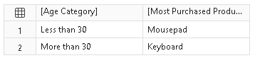

First we need to group the data based on Age below 30 and above 30, then we need to find the count of Order_ID for each Item

* the country that had minimum transactions and sales amount.

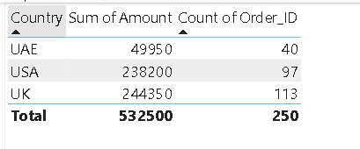

We need to calculate sum of sales and count of Order id group by Country

Here we can see that UAE has minimum transactions and sales